**Lab 3**

**Experiment no. 2**

**Observe the Working Principle of Four Stroke Petrol/Spark Ignition Engine**

* A Four Stroke Engine is an engine which works with four basic steps to a successful rotation of the crankshaft, the intake, compression, power and exhaust stroke.

**Introduction:**

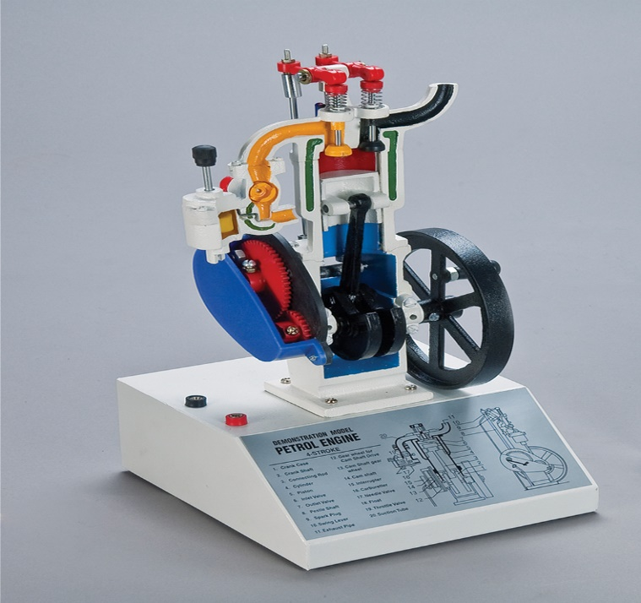A petrol engine is an internal combustion engine with spark-ignition, designed to run on petrol (gasoline) and similar volatile fuels. A four-stroke engine (also known as four-cycle) is an internal combustion engine in which the piston completes four separate strokes which comprise a single thermodynamic cycle. A stroke refers to the full travel of the piston along the cylinder, in either direction. Four stroke cycle engine s is working at completed four stroke of the piston or two revolution of the crank shaft it is called as four stroke engine. There is two types of valves present 1. Inlet valve 2. Exhaust valve. Four stroke petrol Engine working at the four types of stroke **Suction/intake stroke, Compression stroke, Power stroke or expansion stroke** and **Exhaust stroke.** A single cycle requires two revolutions of the crankshaft to complete.

Figure 1: Model of Four Stroke Petrol Engine.

**Parts list and Details:**

The parts of Four Stroke Petrol Engine are much similar to Two Stroke Petrol Engine including

|  |  |  |  |  |  |
| --- | --- | --- | --- | --- | --- |
| **carburetor** | **spark plug** | **crankshaft** | **connecting rod** | **piston** | **cylinder** |

with same working processexcept Inlet and Transfer port which are replace by **Intake Valve** and **Exhaust Valve.** In addition to crankshaft for each cylinder there is another shaft known as **CAM Shaft** for each intake and exhaust valve.

**CAM Shaft:**

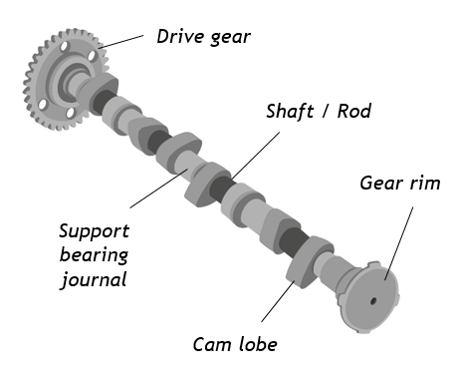In [four-stroke cycle](https://en.wikipedia.org/wiki/Four-stroke_cycle) engines and some [two-stroke cycle](https://en.wikipedia.org/wiki/Two-stroke_cycle) engines, the valve timing is controlled by the [camshaft](https://en.wikipedia.org/wiki/Camshaft). It can be varied by modifying the camshaft, or it can be varied during engine operation by [variable valve timing](https://en.wikipedia.org/wiki/Variable_valve_timing). The camshaft is a mechanical component of an internal combustion engine. It opens and closes the inlet and exhaust valves of the engine at the right time, with the exact stroke and in a precisely defined sequence. The camshaft is driven by the crankshaft by way of gearwheels, a toothed belt or a timing chain.

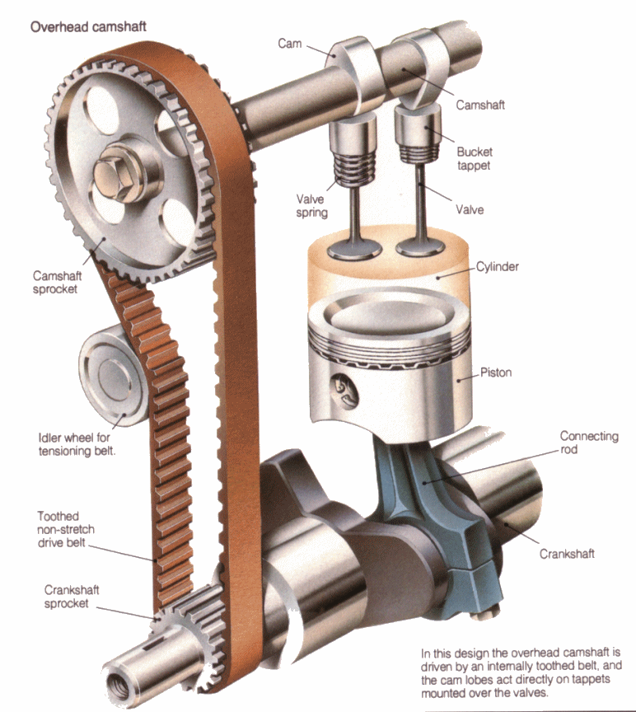

Figure 2:CAM Shaft Model.

**Intake Valve:**

Intake valve let the air-petrol mixture in during Intake stroke. The edge of camshaft pushes the intake valve down and air-petrol mixture enter the cylinder.

**Exhaust Valve**

Exhaust valve is opened when combustion ends. The edge of camshaft pushes the exhaust valve down and burnt gases leave the cylinder.

The intake valves are larger because the air and fuel volume taken in by the engine is greater than the exhaust volume.

**Explanation:**

**Processes:**

There are following processes in Four Stroke Petrol Engine:

* Intake Stroke
* Compression Stroke
* Combustion/Power Stroke
* Exhaust Stroke

**Intake Stroke:**

* It is where the intake valves are open and the air is drawn into the cylinder. The fuel injector sprays the fuel into the cylinder to achieve the perfect air-fuel ratio. The downward movement of the piston causes the air and fuel to be sucked into the cylinder.

**Compression Stroke:**

* In this stroke, both the intake and exhaust valves are closed. The upward movement of the piston causes the air-fuel mixture to be compressed upwards towards the spark plug. The compression makes the air and fuel to be sucked into the cylinder.

**Combustion/Power Stroke:**

* During this stroke, both the intake and exhaust valves are still closed. The spark plug produces a spark to ignite the compressed air-fuel mixture. The resulting energy of the combustion forcefully pushes the piston downward.

**Exhaust Stroke:**

* It is the last stroke, when the exhaust valves are open and the exhaust gases are forced up by the resulting piston.

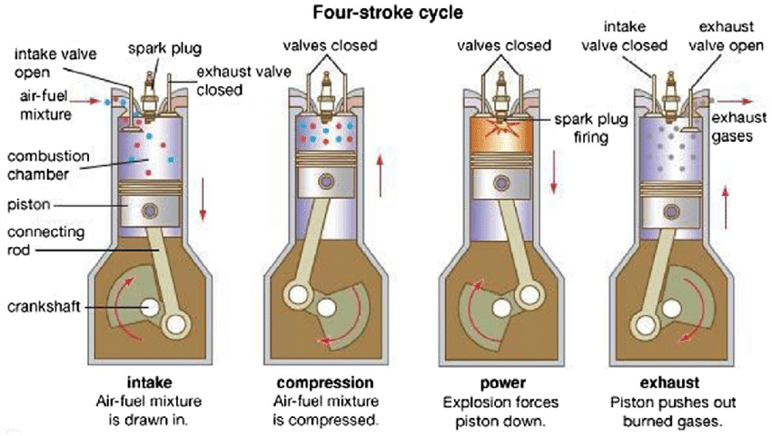

**Figure 3:Four Strokes of Petrol Engine**

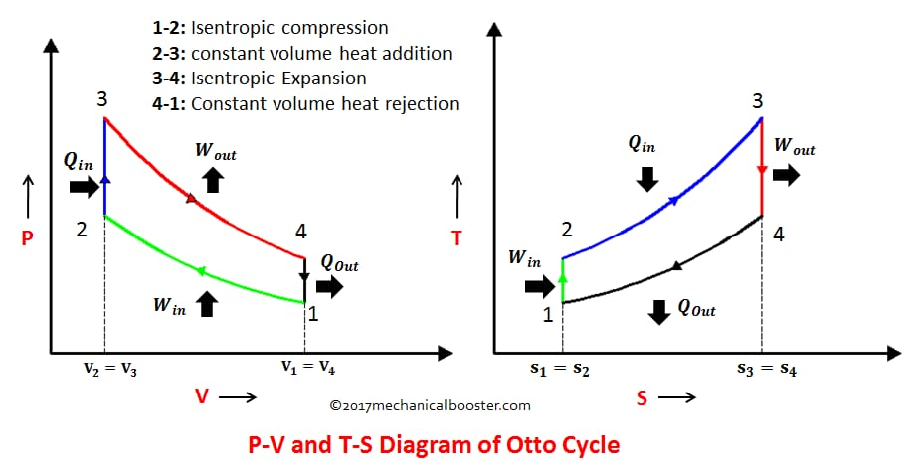

**Figure 4:P-V Diagram and T-S diagram of four stroke Petrol Engine**

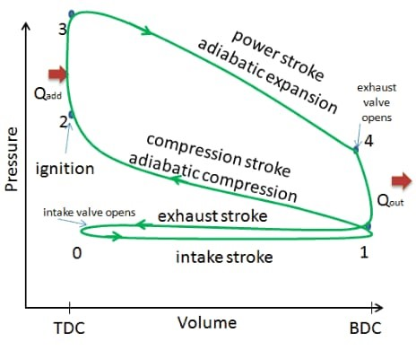

**Figure 5:Actual /Real P-V diagram**

|  |  |
| --- | --- |
| **Advantages** | **Disadvantages** |
| * Less fuel consumption. * Thermal efficiency is more. * More volumetric efficiency. * Less wear and tear. | * More components. * Separate valve mechanism is required. * More cost. * More complicated design. |

**Application:**

The four-stroke version is generally used for larger applications and is the most common type of engine used in automobiles today. This type of engine is an ingenious and practical design that has powered millions of vehicles. It produces a large amount of power in an efficient and effective manner. It also generally produces less pollution and lasts longer than a two-stroke engine. The engine was created by **Nikolas Otto** in the mid-1800s, and in his honor, it's sometimes known as the Otto Engine. The four main strokes or steps that make up the cycle are intake, compression, combustion, and exhaust, which is sometimes called the **Otto** cycle.

* [Automobiles](https://en.wikipedia.org/wiki/Automobile)
* [Motorcycles](https://en.wikipedia.org/wiki/Motorcycle)
* [Aircraft](https://en.wikipedia.org/wiki/Aircraft)
* [Motorboats](https://en.wikipedia.org/wiki/Motorboat)
* [Small engines](https://en.wikipedia.org/wiki/Small_engine), such as [lawn mowers](https://en.wikipedia.org/wiki/Lawn_mower), [chainsaws](https://en.wikipedia.org/wiki/Chainsaw) and portable engine generators.

**Difference between Two Stroke Engine**

**and Four Stroke Engine:**

|  |  |
| --- | --- |
| **Two Stroke Engine** | **Four Stroke Engine** |
| In a 2-stroke engine, the entire combustion cycle is completed with just one piston stroke: a compression stroke followed by the explosion of the compressed fuel. During the return stroke, the exhaust is let out and a fresh fuel mixture enters the cylinder. | being followed by a return stroke. In a 4-stroke engine, the piston completes 2-strokes during each revolution: one compression stroke and one exhaust stroke, |
| It is more powerful. | It is less powerful. |
| The spark plugs fireonce every single revolution, and power is produced once every 2-strokes of the piston. | The spark plugs fire only once every other revolution, and power is produced every 4-strokes ofthe piston. |
| In two stroke engine, one power stroke is there for every two strokes. | In four stroke engine, one power stroke is there for every four strokes. |
| It is less complicated. | It is more complicated. |
| It is less expensive. | It is more expensive. |
| It has ports for pulling in fuel and air. | It has intake and exhaust valves rather than ports for pulling in fuel and air. |
| It produces loud with a high-pitched buzz. | It produces more of a soft humming noise. |
| Here only motion of piston controls the opening and closing of ports. | There is camshafts which control the opening and closing of intake and exhaust valves. |
| Two stroke engine has less parts | Four stroke engine has more parts and heavier. |
| In two stroke engine, there is ports for fuel intake | In four stroke engine, there is valves for intake and exhaust. |
| Two stroke has less efficiency. | Four stroke engine has more efficiency because it consumes less fuel. |
| Two-stroke engines also require the oil to be pre-mixed in with the fuel. | These engines also do not require pre-mixing of fuel and oil, as they have a separate compartment for the oil. |